IRIS 3D Face Modeling
2015.12.23
Computer Vision Lab
Institute for Robotics and Intelligent Systems
University of Southern California
{kim207, jongmooc, Medioni}@usc.edu

Description
This Window library supports 3D face modeling with the PrimeSense or Kinect 1.0 camera. It supports functions of face modeling.

Assumptions
The program is for a single user at a time. The person should not stand farther than 1 meter away from the camera or closer than 40 cm to the camera.
This version requires "frontal faces" as first input for face modeling, and it can cover pose changes. So, this face recognition system can be used for cooperative users.

Structure
This package includes 4 main folders:
- em_icp_cuda6.5\em_icp_cuda6.5\em_icp_cuda6.5\Include: 3rd party libraries in Include folder. (e.g) dlib, openCV, OpenMesh 3.2, OpenNI2, pose estimation, pthreads-w23-2-9-1, boost 1.55.0, CUDA6.5 (depending on graphic card)
- em_icp_cuda6.5\em_icp_cuda6.5\em_icp_cuda6.5\src: Face modeling source code.
- em_icp_cuda6.5\em_icp_cuda6.5\em_icp_cuda6.5\model: Face modeling results of OBJ and PLY format.
- em_icp_cuda6.5\em_icp_cuda6.5\Release: Executable file of the project.

Requirements

Hardware requirements
The program supports PrimeSense or Kinect 1.0 camera. We have tested our program with the following configuration.
CPU: Intel(R) Core(TM) CPU i5-4460 @ 3.20 GHz
Operating system: Windows 7
Compiler: Visual studio 2013
Sensor: PrimeSense Camine 1.08 with OpenNI2 (http://structure.io/openni)
Graphic Card: NVIDIA GeForce GTX750

Software requirements
Note: The library was compiled under win32 model. Please make sure your OpenNI2 or other libraries are the version for windows 32bit system to compile the IRIS 3D modeling. All other libraries are already in the Include folder.
This program has been tested under the specifications of the computers:
- Visual Studio 2013.
- CUDA ToolKit 6.5.
http://developer.download.nvidia.com/compute/cuda/6_5/rel/docs/CUDA_Getting_Started_Windows.pdf

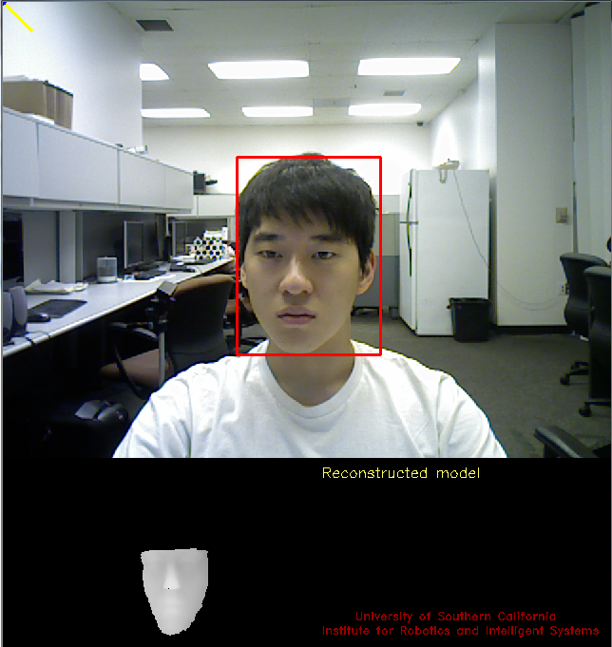
Figure 1. Example of a face modeling.
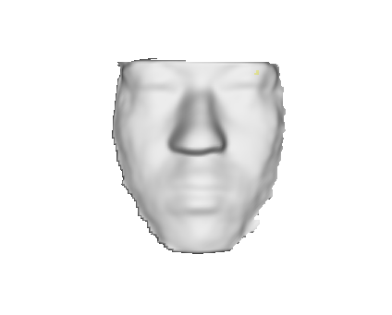
Figure 2. Example of modeling results. This results will be stored as obj and ply format.
mymodel.obj, mymodel.ply or InputRecordFile.obj and InputRecordFile.ply

Running the example code

Setup
- Install Visual Studio 2013.
- Install CUDA Toolkit 6.5 (https://developer.nvidia.com/cuda-toolkit-65)
- Configure the project properties
  - Go to Configuration Properties → C/C++ → General → Additional Include Directories. Include additional include directories, shown in Figure 3.
  - Go to Configuration Properties → Linker → General → Additional Library Directories. Include additional library directories, shown in Figure 4.
  - Go to Configuration Properties → Linker → Input → Additional Dependencies.
    - OpenMeshCore.lib, OpenMeshTools.lib, freeglut.lib, OpenCL.lib, MSVCRT.lib, LIBCMT.lib, lapack.lib, blas.lib, libf2c.lib, OpenNI2.lib, opencv_calib3d249.lib, opencv_contrib249.lib, opencv_core249.lib, opencv_features2d249.lib, opencv_flann249.lib, opencv_gpu249.lib, opencv_highgui249.lib, opencv_imgproc249.lib, opencv_legacy249.lib, opencv_ml249.lib, opencv_nonfree249.lib, opencv_objdetect249.lib, opencv_ocl249.lib ,opencv_photo249.lib, opencv_stitching249.lib, opencv_superres249.lib, opencv_ts249.lib, opencv_video249.lib, opencv_videostab249.lib, cudart.lib, cublas_device.lib, cudadevrt.lib, cublas.lib, cudart_static.lib, cufft.lib, cufftw.lib, curand.lib, nvcuvid.lib, nppc.lib, nppi.lib, cusparse.lib, cuda.lib, kernel32.lib, user32.lib, gdi32.lib, winspool.lib, comdlg32.lib, advapi32.lib, shell32.lib, ole32.lib, oleaut32.lib, uuid.lib, odbc32.lib, odbccp32.lib
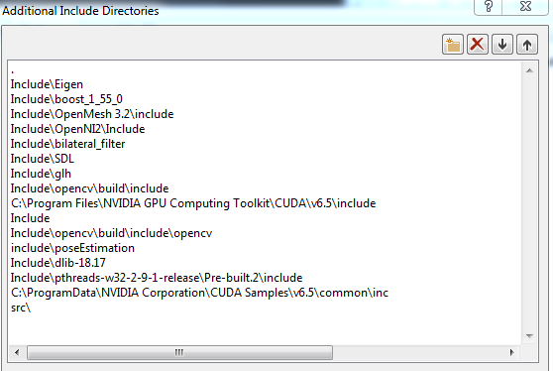
Figure 3. Configure additional include directories.
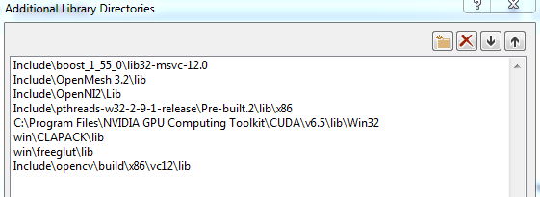
Figure 4. Configure additional library directories

- Compile & run the output executable file through visual studio 2013.
  - Executable file will be placed in em_icp_cuda6.5\em_icp_cuda6.5\Release.
  - You can execute executable file after moving this file into the em_icp_cuda6.5\em_icp_cuda6.5\em_icp_cuda6.5.

Test 1, face modeling
- Test 1 demonstrates how to use the IRIS 3D face modeling program for face modeling with depth and rgb sensor.
To run this test, PrimeSense or Kinect 1.0 camera is required.
- After starting, the program will display the RGB frames in real time & detected face bounding box. This program also will display a modeled face in real time. Here are your options for other processes:
- Press key 'r' to reset a face modeling and start to make a new face modeling. The assumption of the program is that the first frame should be a frontal face. You can adequately choose a first frame which is a frontal face by resetting.
- Press key 'd' to switch between the depth and the RGB display.
- Press key 'q/ESC' to exit the program and produce the modeled face as OBJ and PLY file. The default output file is ./model/mymodel.ply, ./model/mymodel.ply
To visualize your output, open it with MeshLab http://meshlab.sourceforge.net/
- Press key '8' to use previous version of face modeling
- Press key '9' to use version of face modeling which filters frames based on head pose.
- Press key '0' to use proposed version of face modeling, landmark based pose estimation, filtering frames and segmentation of face region.

Test 2, face recognition with PLY file from face modeling.
- Test 2 demonstrates how to use PLY files from face modeling for finding recognition rates. We will use the IRIS 3D face recognition library to measure distances between references and inputs. Before using the IRIS 3D face recognition, you may need to read the document of the IRIS 3D face recognition for details.
- To run this test:
- We assume that there are at least two PLY files from results of face modeling.
- You can open the FaceLibSample project in the IRIS 3D face recognition to see the example usage of FaceRecLib libraries.
- You should enroll reference PLY files.
  - (e.g) frlib.enrollPLY(fpath, fname, autorestart);
- You can measure the distances between input and references.
  - (e.g) frlib.identifyPLY(fpath, faces, times);

- Results:
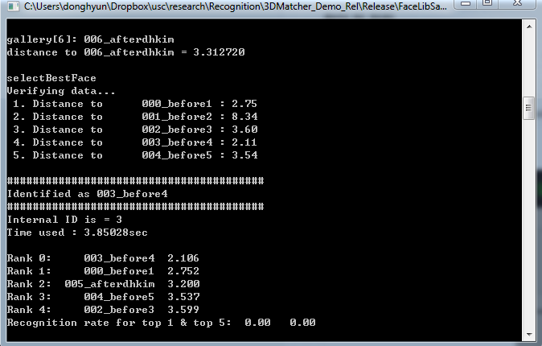

Summary
We briefly introduced the IRIS 3D face modeling and its usage with the IRIS 3D face recognition. The test examples mentioned above are basic scenarios. You can modify these programs for your own purpose.

Developers
Donghyun Kim, Jongmoo Choi, Gérard Medioni

